Contents
1. Introduction 2
2. Application Architecture 2
3. Model Integration 2
3.1 Classification Model 2
3.2 Segmentation Model 3
4. Backend–Frontend Integration 3
6. Technology Stack 6
7. Workflow Diagram 6
8. Conclusion 6

Integration of MRI Classification and Segmentation Models into a Web Application

1. Introduction
The goal of this project is to integrate deep learning models for MRI classification and segmentation into a user-friendly web application. This allows medical professionals to upload MRI scans, analyze results, and manage patient data seamlessly. The system provides real-time inference, visual results, and persistent storage of patient records.

2. Application Architecture
The application follows a client–server architecture, comprising:
- Frontend (React.js)
  - Handles user interactions, file uploads, and displays results.
  - Pages include:
    - Upload Page: Allows users to upload MRI scans.
    - Results Page: Displays classification and segmentation outcomes.
    - Patient Data Page: Shows saved patient records with images and details.
  - Uses CSS and inline styling for professional UI design.
- Backend (Flask/Python)
  - Handles API requests from the frontend.
  - Performs inference using pre-trained classification and segmentation models.
  - Stores patient data and images in a structured folder (data/images/) and maintains metadata for retrieval.

3. Model Integration

3.1 Classification Model
- Determines tumor type and confidence score from uploaded MRI images.
- Implemented in TensorFlow/Keras with a pre-trained architecture.
- Backend API:
- POST /classify
  - Accepts MRI images, returns predicted tumor type and confidence.

3.2 Segmentation Model
- Segments the tumor region in MRI images.
- Produces output images highlighting tumor boundaries.
- Backend API:
- POST /segment
  - Returns a segmented image saved on the server.

4. Backend–Frontend Integration
- File Upload
  - Users upload MRI scans via React frontend.
  - Frontend sends files to backend endpoints (/classify and /segment) using Axios.
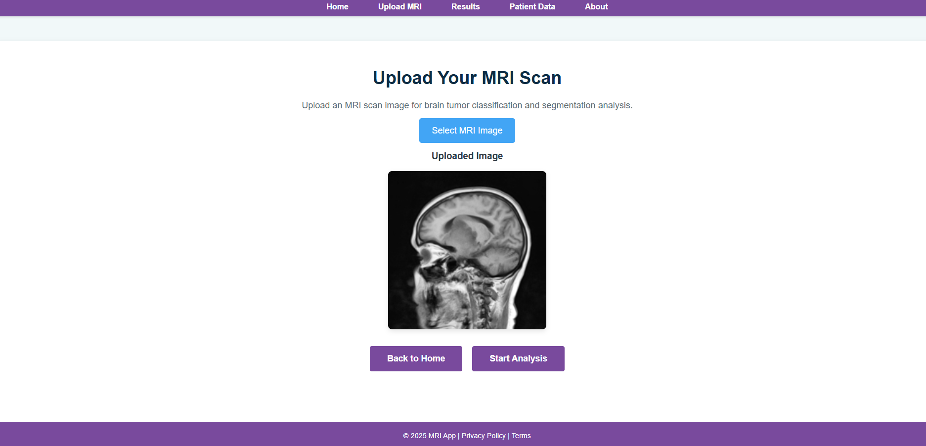
- Inference
  - Backend models process the images.
  - Classification results (tumor type, confidence) and segmented images are returned to the frontend.
- Result Display
  - Results Page shows:
    - Original MRI.
    - Segmented MRI.
    - Tumor classification and confidence.
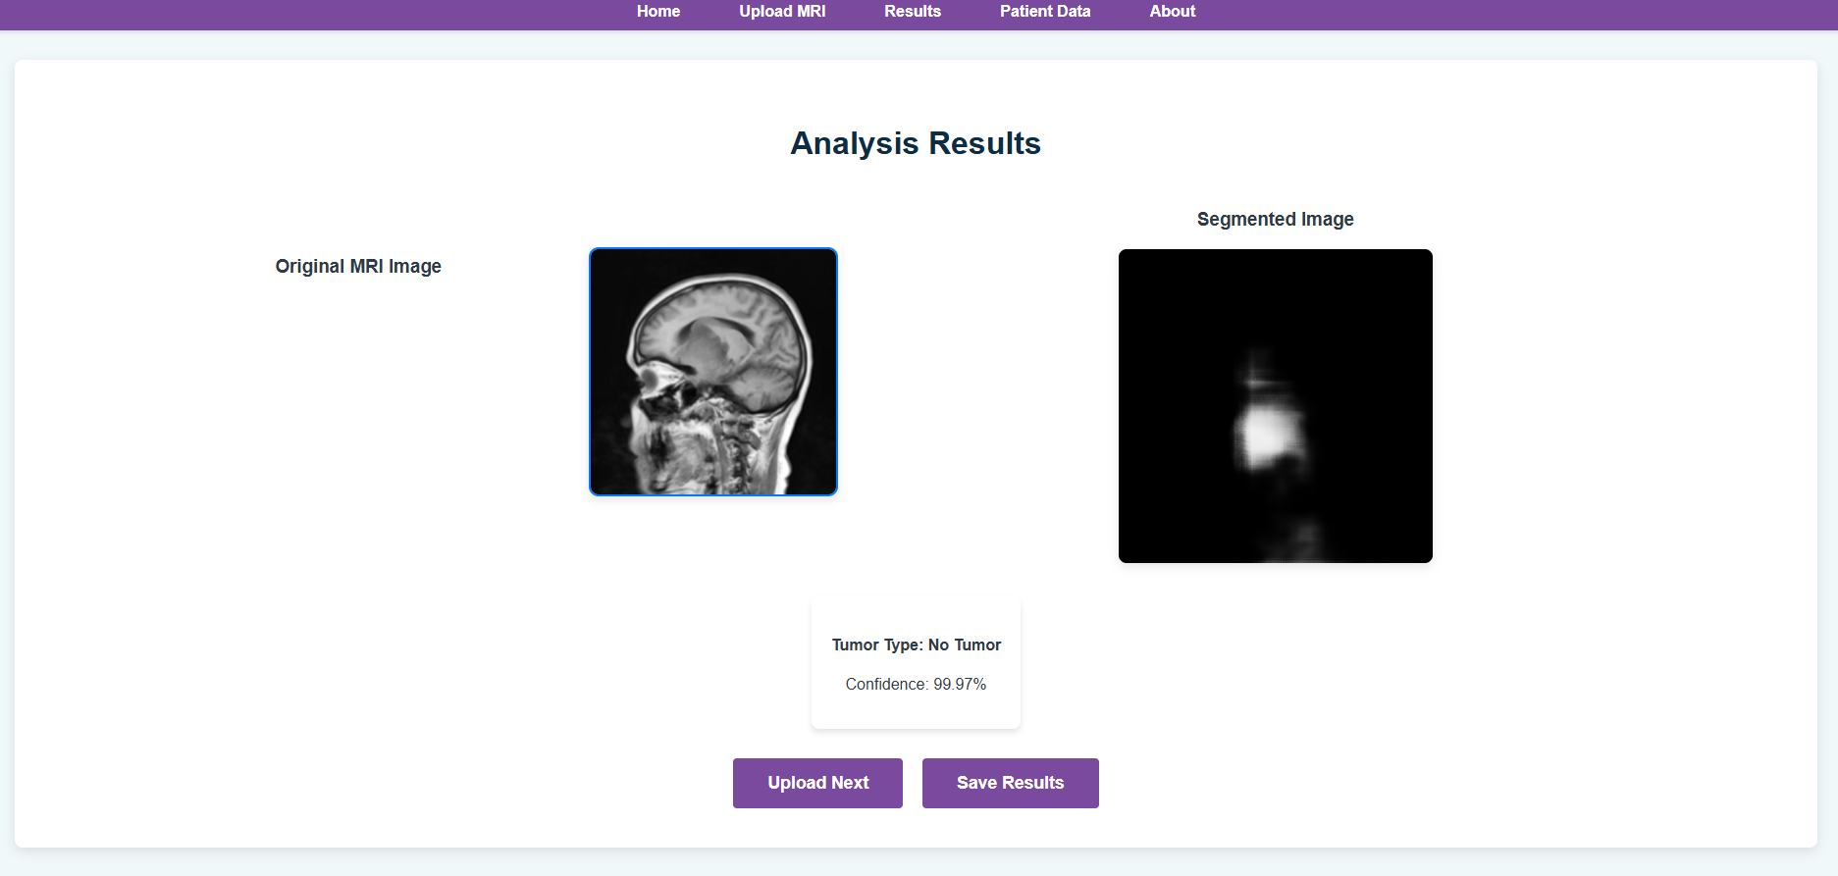
- Data Storage
  - All uploads, predictions, and metadata are saved in the backend (data/images/ and database or JSON storage).
  - Patient data includes:
    - Name
    - Tumor Type
    - Confidence
    - Date & Time
    - Original & Segmented images
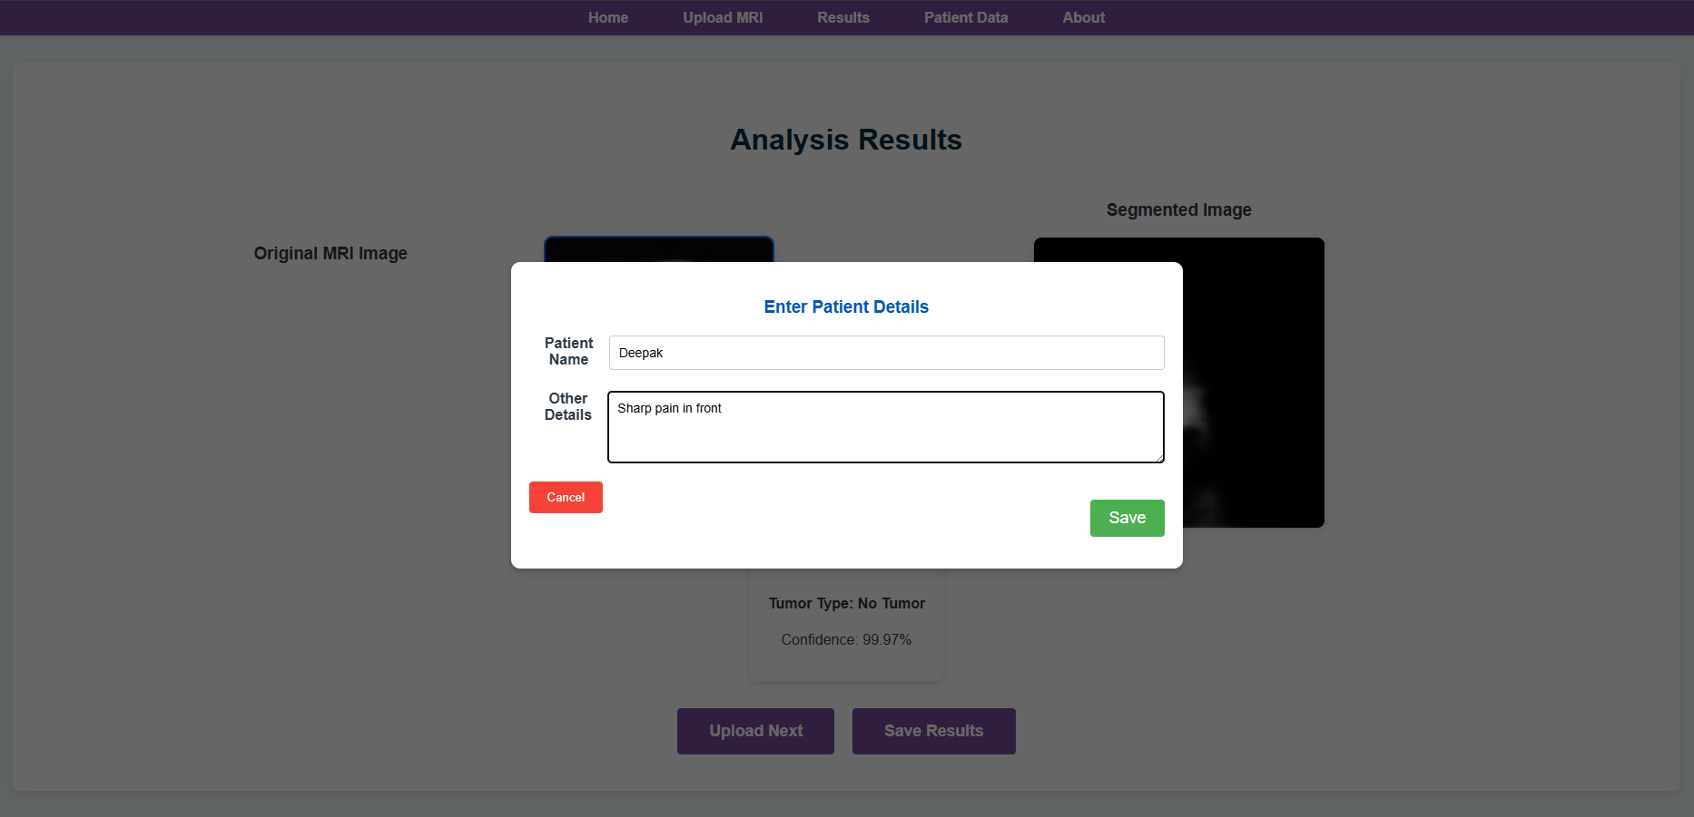
- Patient Data Page
  - Retrieves stored patient records via API (/get-patient-data).
  - Displays a table with all metadata and image previews.
  - Supports viewing original and segmented images in a modal with a horizontal layout.
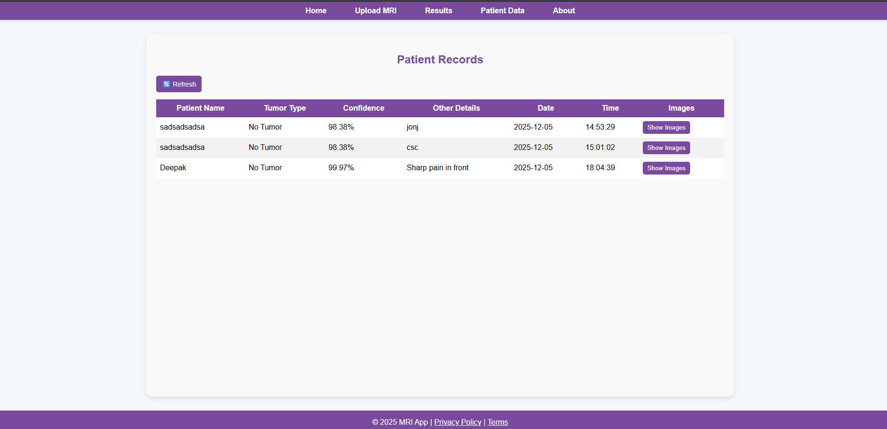
5. Key Features
- Full-stack integration: Deep learning models seamlessly integrated with React frontend.
- Image visualization: Horizontal layout of original vs segmented MRI images.
- Persistent data storage: Patient records, predictions, and images are stored for later retrieval.
- User-friendly interface: Professional UI with navigation, refresh button, and modal image viewing.
- Responsive design: Layout adapts to different screen sizes.

6. Technology Stack
Layer | Technology
Frontend | React.js, HTML, CSS
Backend | Python Flask
Machine Learning | TensorFlow/Keras
Storage | Local server folders (data/images)
Communication | REST APIs (Axios for frontend)

7. Workflow Diagram
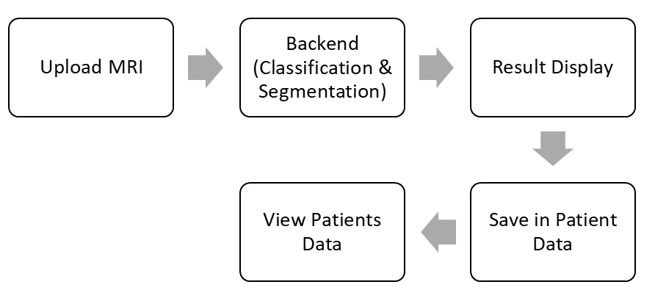

8. Conclusion
The integration of classification and segmentation models into a web application provides:
- Real-time medical image analysis.
- Easy access and management of patient data.
- A professional interface for clinicians and researchers.
- Modular architecture for future expansion (e.g., adding new models or AI analytics).
The system effectively bridges the gap between deep learning model outputs and a practical, usable interface for medical applications.

